Spring API Gateway Filters
- GlobalFilter
  - You can implement a global filter by implementing the interface GlobalFilter
  - After that, you need to write the implementation of the method
Mono<Void> filter(ServerWebExchange exchange, GatewayFilterChain chain)
    - This GatewayFilterChain is just to transfer the call to next filter.
    - ServerWebExchange contains all the details like request, response, attributes ..etc.
  - You don’t need to append this to any specific route, this filter will be attached to every request that goes through the spring cloud api gateway server.
  - Make sure to make the custom global filter as a Component.
  - 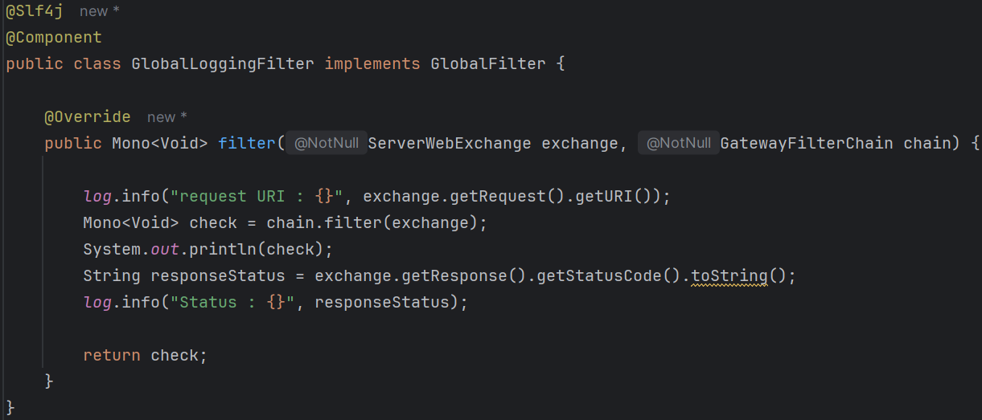
    - Its WRONG ❌
    - chain.filter(exchange) that is to execute the next filters.
    - The GatewayFilterChain contains the details about request, it contains response as well but that is null initially, only after the request is executed response will be there.
Again, the response will not be there inside that same GatewayFilterChain object.
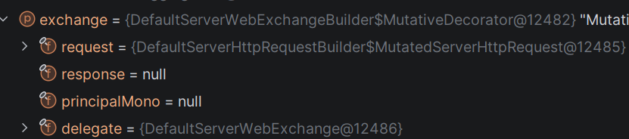
You can see, response is null currently.
And, this filter method’s return type is Mono so only after it is subscribed the response will be present.
    - In chain you can see all the filters.
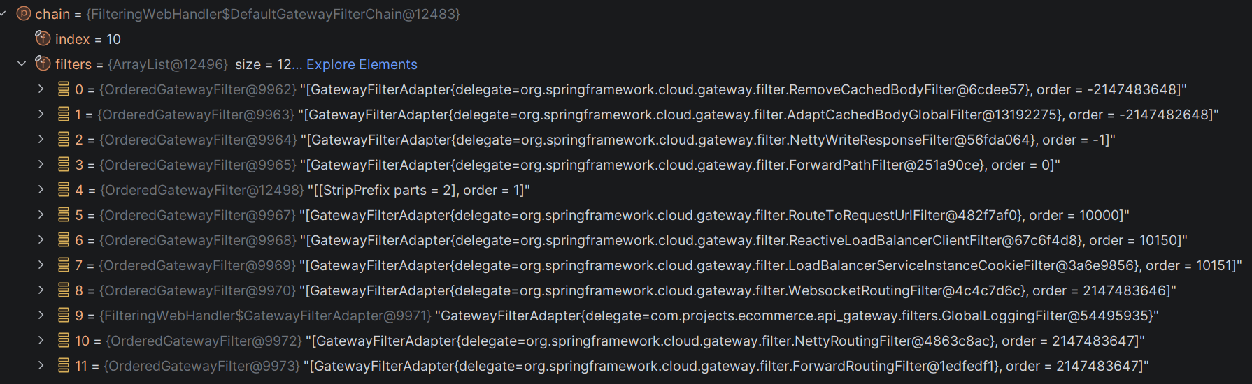
      - At index 9, you can see our GlobalLoggingFilter.
  - The correct way to access the response is the below
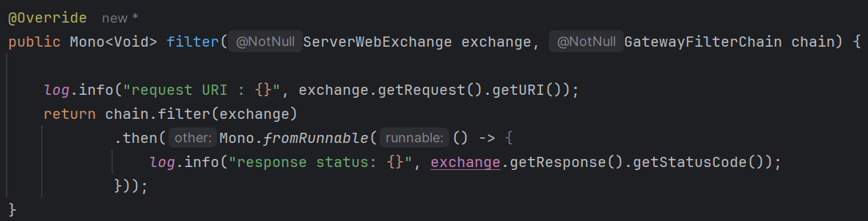
    - Here, we are logging the response only after the Mono (returned object) is subscribed.
Means, that then method is executed only after the Mono is subscribed.
  - Now, if you want to set the order (here it is coming at index 9 as we saw earlier), then you can implement the Order interface.
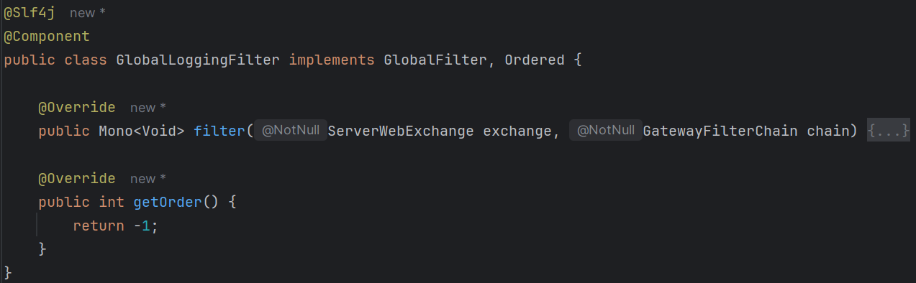
    - Lowest value : highest priority
    - 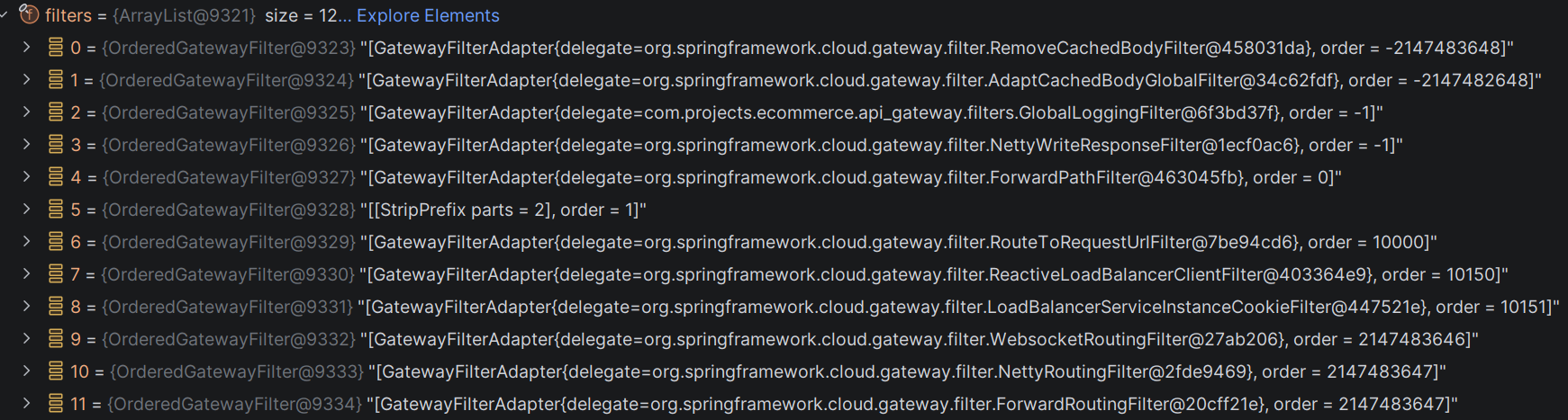
    - If you see now, its there at index 2
    - The last values are orders, there are some filters having negative infinity ordered so they are at index 0 and 1.
  - I wrote 2 custom global filters, all same, the execution order is like
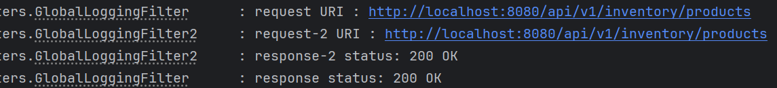
    - Before then, first to last
    - After then, last to first
  - As you can see, you are passing exchange to the chain.filter() method, so here the exchange object will be properly updated and you can access the response after that.
- GatewayFilter (Default)
  - These filters can be added to specific routes.
  - In simple terms, Gateway Filters are route-specific filters.
  - 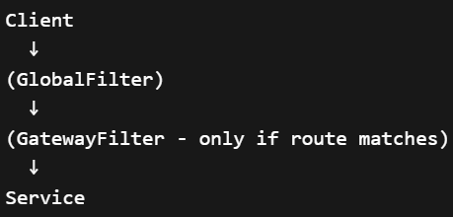
  - There are built-in gateway filters there like
AddRequestHeader, AddRequestHeadersIfNotPresent, AddRequestParameter, …etc
  - I added the following headers
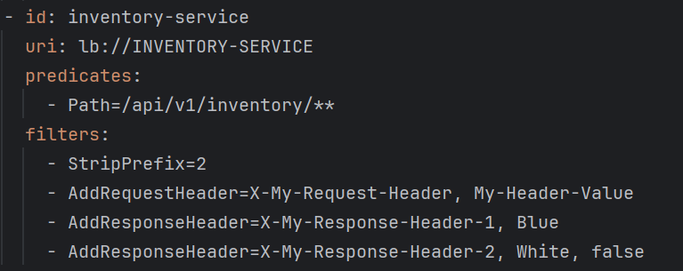
    - Request header will be appended to request and can be accessed from the specific services.
    - Response headers will be attached to the response object got from the service and can be accessed from the client side.
      - 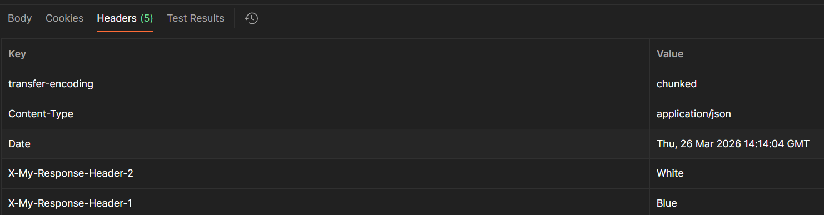
- GatewayFilter (Custom)
  - To create custom gateway filters, you have to implement the abstract class AbstractGatewayFilterFactory.
  - There is a method getConfigClass() in both GatewayFilterFactory and Configurable, but in when same method is written in 2 places, Java always select the method present in class instead of interface.
  - You need to create a static class in your custom gateway filter factory class and pass that as the generic, it is required and will be helpful if you want to pass any argument to the gateway filter from yaml file.
  - 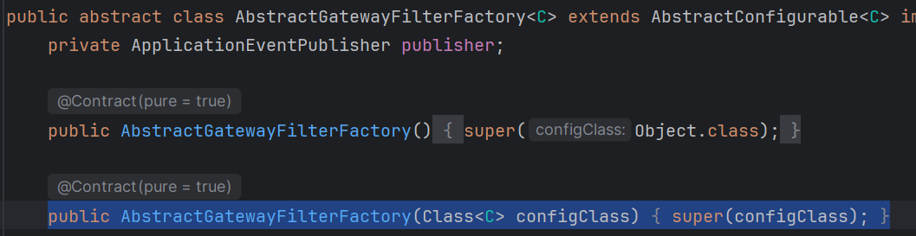
  - 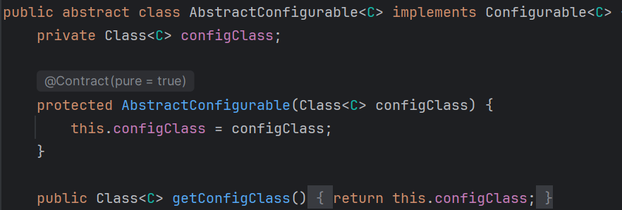
  - You need to pass the object of type Class i.e. <your config class>.class
  - 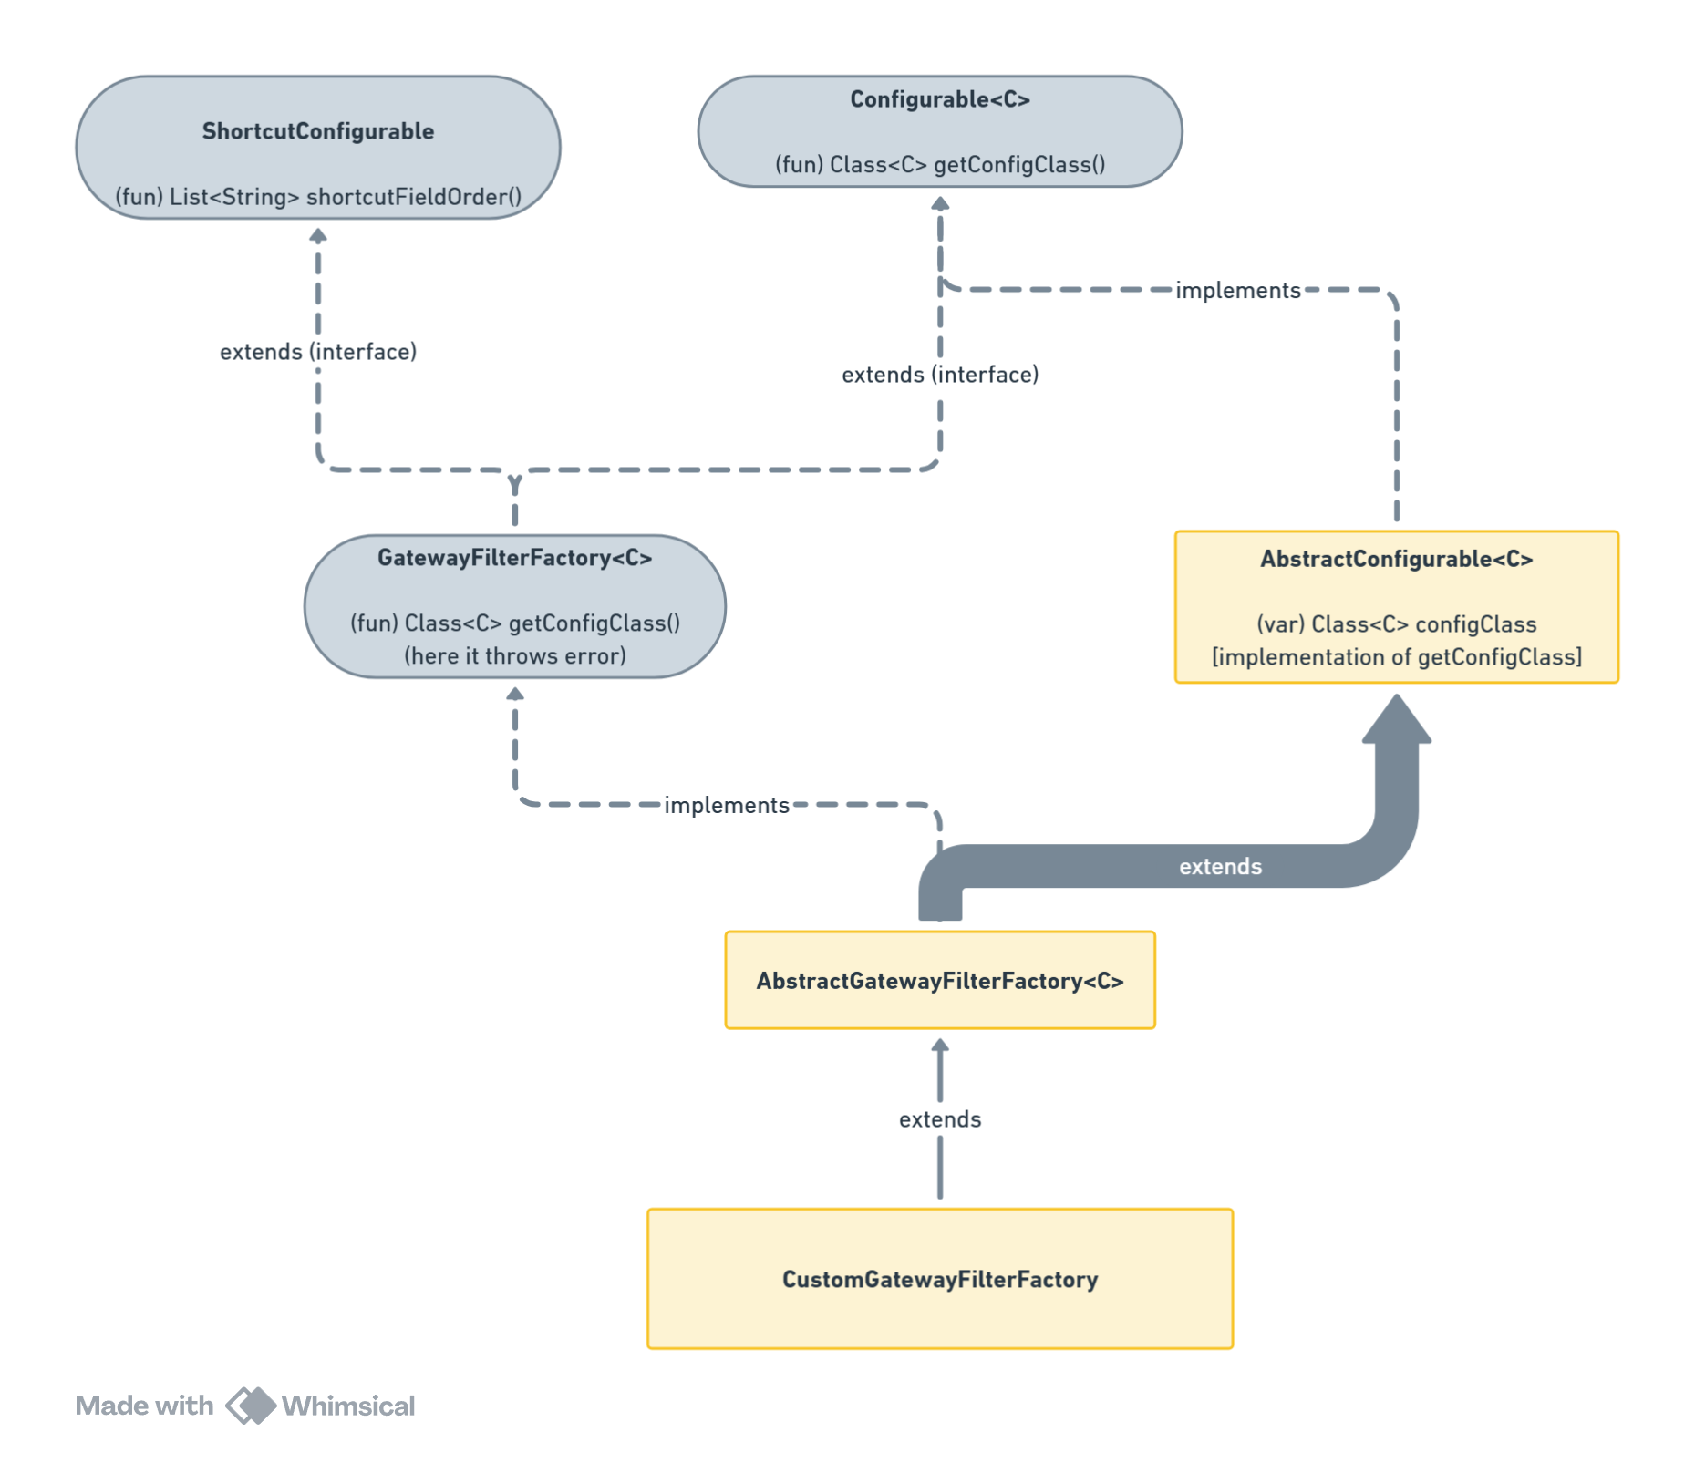
  - You need to implement the GatewayFilter apply(Config config) method
    - GatewayFilter is nothing but a functional interface that contains a filter method which contains exchange and chain just like the GlobalFilter case.
    - 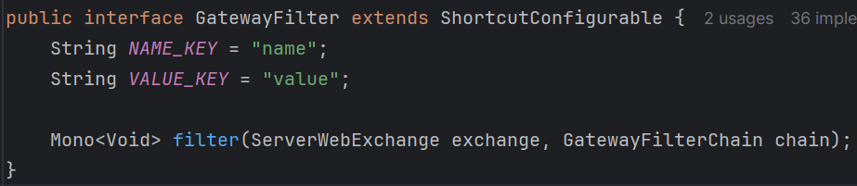
  - Also, make sure to make the custom gateway filter factory class a component.
  - 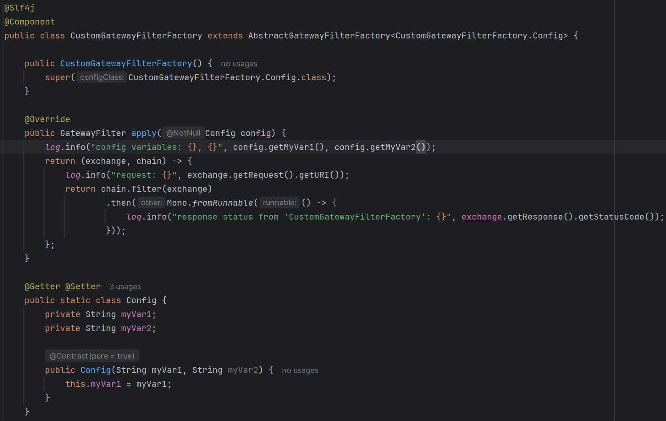
    - Because GatewayFilter is a functional interface, so you can directly use lambda syntax for that.
  - If your custom gateway filter factory class has suffix as GatewayFilterFactory (in my case CustomGatewayFilterFactory) then you must directly write Custom in that case in the application.properties or yaml file.
  - You can mention this filter in application file like the below passing the arguments
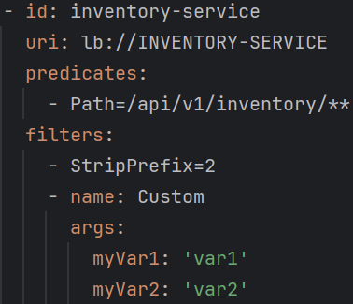
  - If you want to pass the argument in a single line, then you need to write the implementation of the method shortcutFieldOrder() ( which is present in ShortcutConfigurable interface )
    - 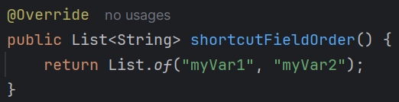
myVar1 and myVar2 are the variable names, and when you pass the argument the order should be same.
      - Means, first will be assigned to myVar1, 2nd will be to myVar2
    - 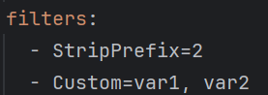
    - Now, if I change the order
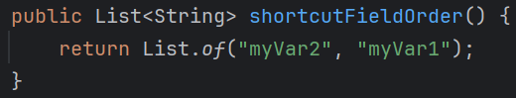

  - You can use the api gateway to authenticate the user as well like jwt token authentication and all, if user is authenticated then trigger the request to micro services otherwise not. A small example of that
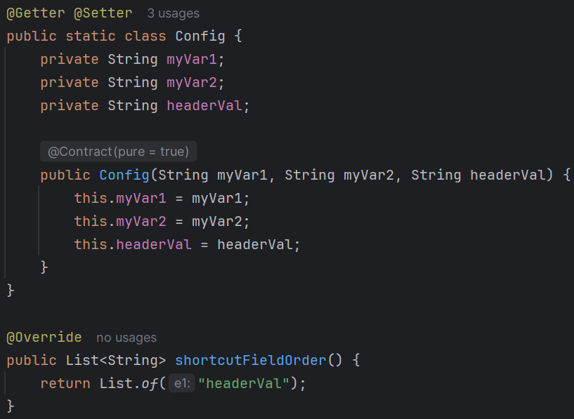
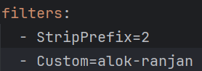.
    - Now only headerVal variable will be assigned, nmyVar1 and myVar2 will be null because I removed those from the shortcutFieldOrder() method.
    - In the long format of application, you can assign the values.
 (like this)
    - My concept here is, in the request (from postman), I’ll give a header having key “custom-header”, if its value is “alok-ranjan” then it’ll forward to services otherwise not.

    - 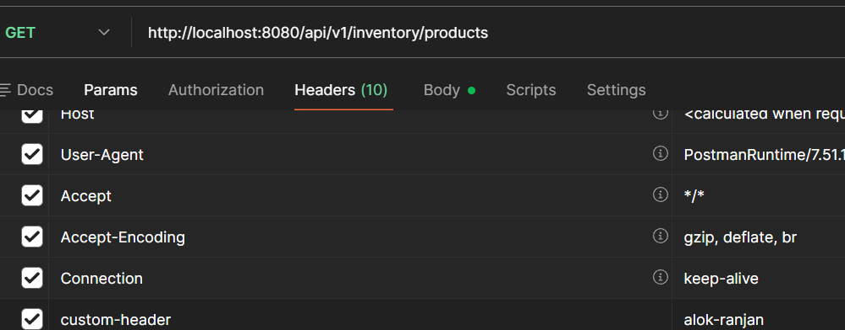
  - 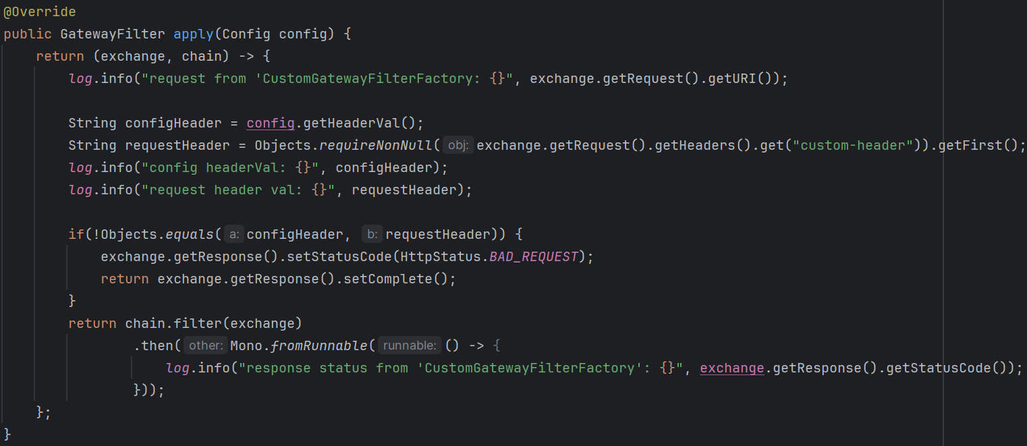
    - Only in case of correct header, the request will be forwarded otherwise not.

- F
- F
- F
- F
- F
- F

